**Alisher Siddikov**

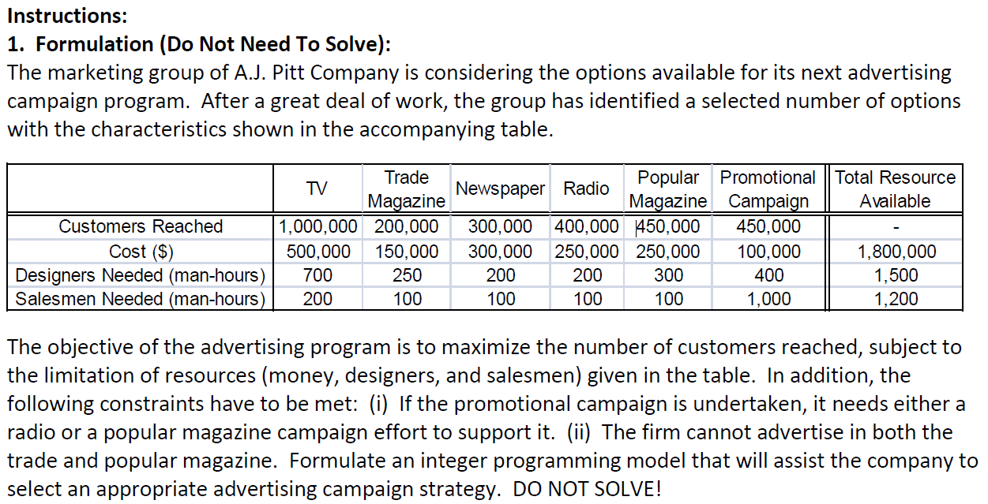

*The following numbers are in hundreds*

**Decision variable:**

Campaigns:

x1 = TV

x2 = Trade Magazine

x3 = Newspaper

x4 = Radio

x5 = Popular Magazine

x6 = Promotional

**Objective:**

max: 10,000 x1 + 2,000 x2 + 3,000 x3 + 4,000 x4 + 4,500 x5 + 4,500 x6

**S.T.**

5,000 x1 + 1,500 x2 + 3,000 x3 + 2,500 x4 + 2,500 x5 + 1,000 x6 <= 18,000 (restriction 1: money)

7 x1 + 2.5 x2 + 2 x3 + 2 x4 + 3 x5 + 4 x6 <= 15 (restriction 2: designer)

2 x1 + 1 x2 + 1 x3 + 1 x4 + 1 x5 + 10 x6 <= 12 (restriction 1: money)

x4 + x5 − x6 >= 0(restriction 3: promotional campaign; x4 + x5 >= x6)

x2 + x5 <= 1 (restriction 4: cannot advertise both)

x1, x2, x3, x4, x5, x6 >= 0